**IMPLEMENTATION & USER INTERFACE**

**Fig.1: Main Window Fig.2: Voice Calculator**

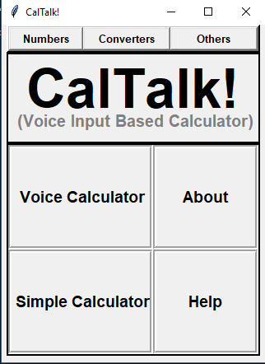 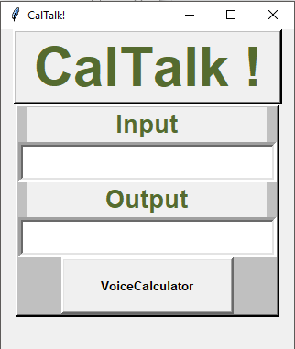

**Fig.3 : Algebra Window Fig.4: Unit Converter**

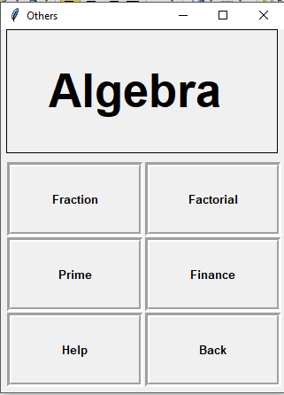 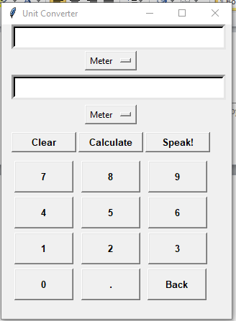

**Fig.5: Finance Fig.6: Rate Calculator**

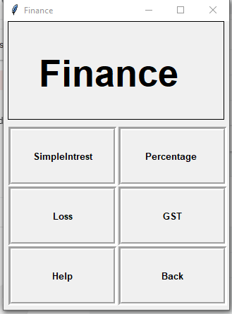 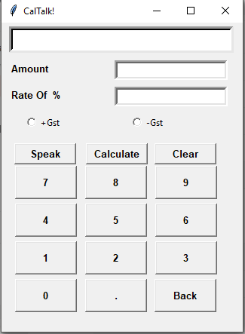

**Fig.7: Profit Loss Fig.8: Simple Interest**

